# Website Design Inspiration

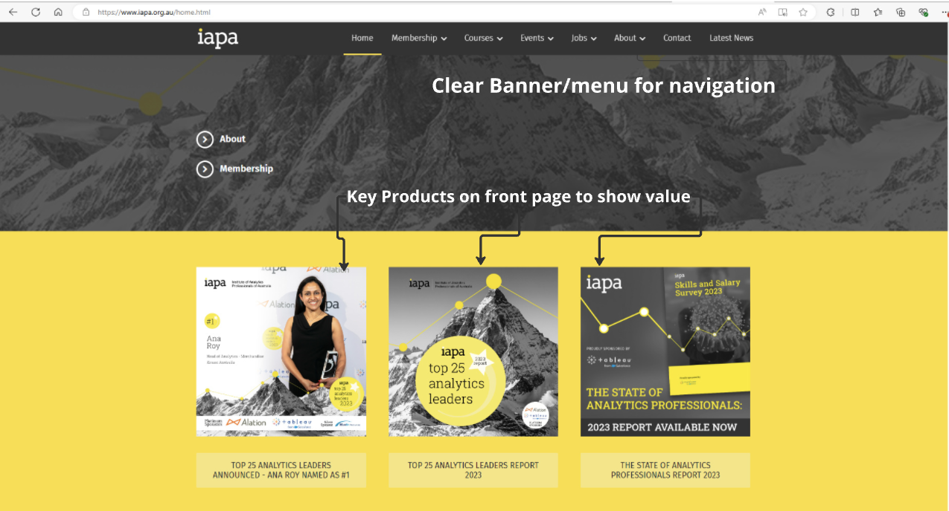

1. The front page is bringing very quick attention to the key propositions of the business
2. The banner/menu is very clear with indicators of selection
3. Standout background colour

1. Notification banner at the top of page highlights any key message the business wants to give the viewer
2. Center of the page are clear call-to-action of the viewer
3. The main page communicates clearly the purpose of the buiness

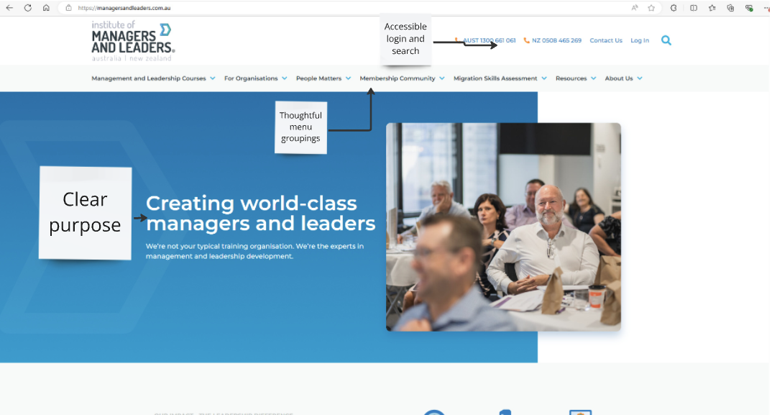

1. The menu groupings (titles) are thoughtful, enticing the user to look deeper into the options
2. Having the login and search in the top right corner gives the user quick access to content and personalisation on the website
3. Similar to previous, the main page highlights a clear purpose statement

1. Using pictorials to communicate key values drivers of the business.